

**Universal Stationary**

# Dux High Quality Eraser 40Pcs Pack



Price: PKR 590

Description:

Ditch frustrating erasing with the Dux High-Quality Eraser Pack! These 40 beauties deliver precision erasing without smudging or tearing paper. Soft, non-toxic rubber tackles even the trickiest graphite marks, leaving your work clean and pristine.

But this pack isn't just for artists. Students, note-takers, and anyone who relies on pencils will appreciate their versatility. They work wonders on various surfaces, including wood, canvas, and plastic, making them truly all-purpose erasers.

No need to worry about constant replacements! Each Dux eraser is built to last, resisting crumbling and breaking even with heavy use. The 40-pack ensures you'll always have one on hand, making it an economical and long-lasting solution.



**Universal Stationary**

ART RANGER ACRYLIC PAINT MARKER 18MM 60ML



Price: PKR 550.00

Description:

The ART RANGER ACRYLIC PAINT MARKER is a versatile tool for artists. With an 18mm tip and vibrant colors, it allows for bold and expressive creations.



**Universal Stationary**

ART RANGER ACRYLIC SET 12 X12 ML

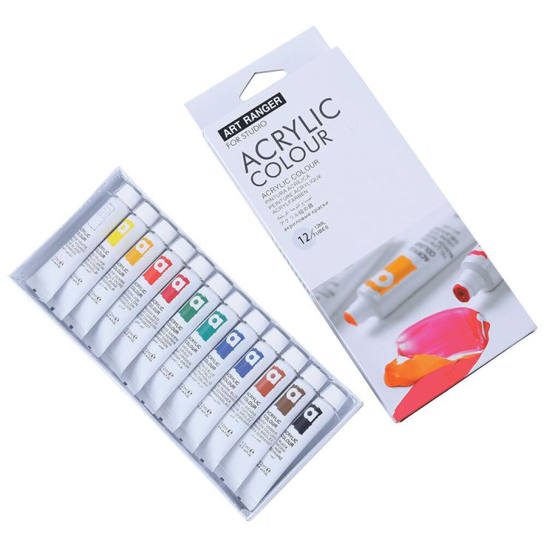

Price: PKR 750

Description:

The ART RANGER ACRYLIC SET offers 12 essential colors in convenient 12ml tubes. Ideal for various art projects, this set is a must-have for any artist.



**Universal Stationary**

Art Rite Canvas 16×20 Inch



Price: PKR 1600

Description:

The Art Rite Canvas in 16×20 Inch size provides a sturdy and smooth surface for artists. Suitable for various painting techniques, it's an essential canvas for your artistic endeavors.



**Universal Stationary**

Art Rite Mini Canvas Deal Of 20 Pcs



Price: PKR 2700

Description:

The Art Rite Mini Canvas Deal includes 20 small canvases, perfect for creating mini masterpieces. Great for experimentation and showcasing your artistic skills.



**Universal Stationary**

Dux High Quality Eraser 40Pcs Pack



Price: PKR 100

Description:

The Art Rite Premium Artist Canvas is a single canvas that ensures quality for your artwork. Suitable for various mediums, it's an excellent addition to your art supplies.



**Universal Stationary**

Art Rite Premium Artist Round Canvas



Price: PKR 250

Description:

The Art Rite Premium Artist Round Canvas offers a unique shape for your artistic expression. With a smooth surface, it's perfect for creating circular artworks.



**Universal Stationary**

Artella Best Mix Media Sketchbook 250gsm 32 Sheet 9x12 inch

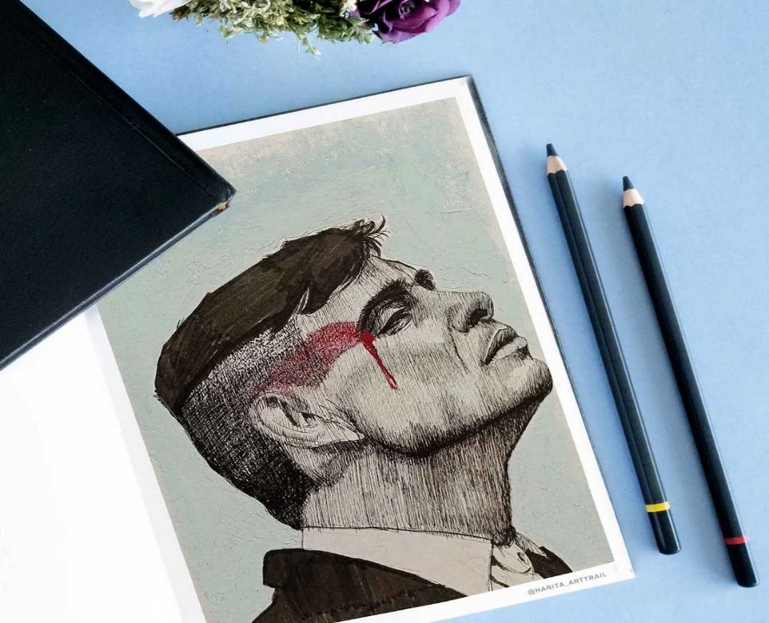

Price: PKR 1500

Description:

The Artella Best Mix Media Sketchbook is designed for various art mediums. With 250gsm paper and 32 sheets, it provides a reliable surface for your creative exploration.



**Universal Stationary**

Bahadur Ego Pencil With Eraser 48 Pcs

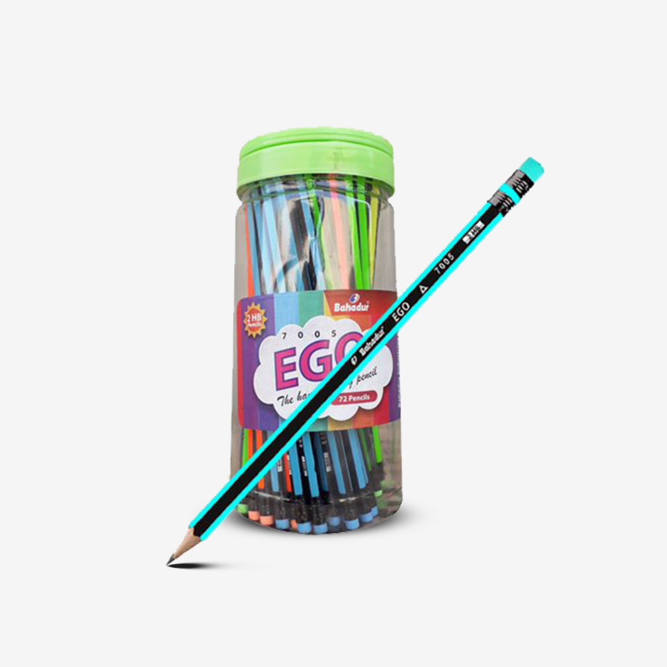

Price: PKR 1400

Description:

The Bahadur Ego Pencil Set includes 48 high-quality pencils with built-in erasers. Ideal for drawing, sketching, and everyday writing.



**Universal Stationary**

Bahadur Trica Golden Graphite Pencil 2HB 12 Pcs

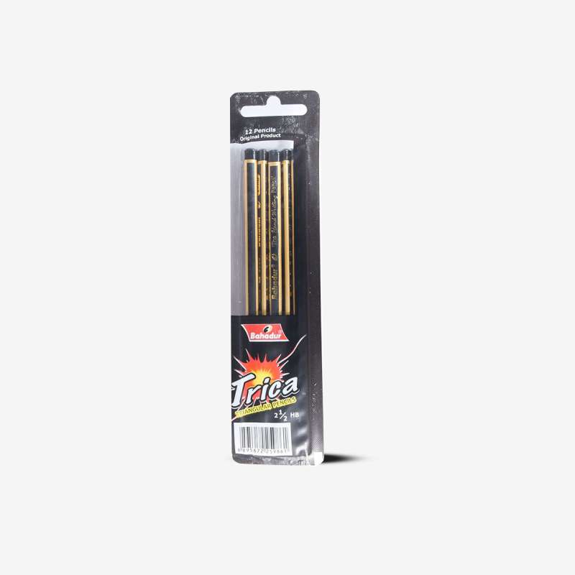

Price: PKR 330

Description:

The Bahadur Trica Golden Graphite Pencil Set offers 12 pencils with a 2HB hardness, providing smooth and consistent lines for your artistic and writing needs.



**Universal Stationary**

Butterfly Foil Journals Notebook



Price: PKR 450

Description:

The Butterfly Foil Journals Notebook features a beautiful foiled cover, adding a touch of elegance to your writing or sketching.



**Universal Stationary**

CASIO Scientific Calculator (FX-991ESPLUS) 417 Functions [PD][1Pc]



Price: PKR 1350

Description:

The CASIO Scientific Calculator FX-991ESPLUS is equipped with 417 functions, making it an essential tool for students and professionals.



**Universal Stationary**

CASIO SCIENTIFIC CALCULATOR FX-350ES PLUS ORIGINAL [IP][1Pc]



Price: PKR 2690

Description:

The CASIO SCIENTIFIC CALCULATOR FX-350ES PLUS is a versatile calculator with 417 functions, ideal for students and professionals. Its 2-line display and statistical functions make it an essential tool for mathematical tasks.



**Universal Stationary**

Cretacolor Kneaded Eraser



Price: PKR 240

Description:

The Cretacolor Kneaded Eraser is an artist's best companion. Its pliable texture allows for precision erasing, making it perfect for creating highlights and detailed artwork.



**Universal Stationary**

Cretacolor Natural Charcoal Stick Single Piece



Price: PKR 120

Description:

The Cretacolor Natural Charcoal Stick offers rich and deep tones for expressive drawings. Ideal for both beginners and professional artists, this single piece allows for versatile sketching techniques.



**Universal Stationary**

CRETACOLOR WOODLESS GRAPHITE PENCILS FOR DRAWING



Price: PKR 495

Description:

The CRETACOLOR WOODLESS GRAPHITE PENCILS set is a drawing enthusiast's dream. With a range of tones, these pencils are perfect for various drawing techniques, offering smooth and consistent results.



**Universal Stationary**

DALER ROWNEY ACRYLIC COLOR



Price: PKR 2050

Description:

Unleash your creativity with DALER ROWNEY ACRYLIC COLOR. With high-quality pigments, these acrylic colors deliver vibrant and long-lasting results, making them a favorite among artists.



**Universal Stationary**

DALER ROWNEY AQUAFINE ROUND BRUSHES AF85

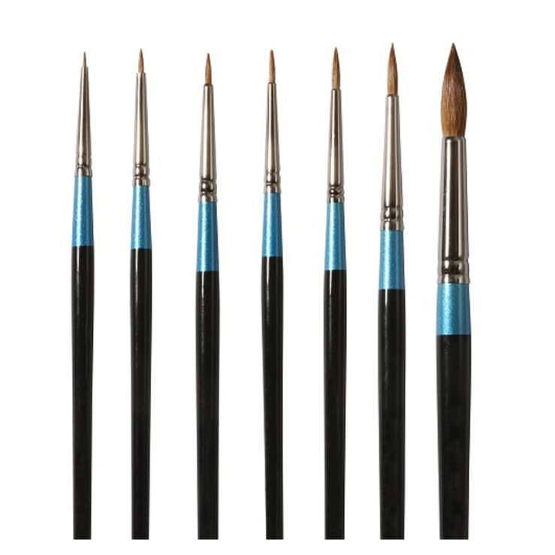

Price: PKR 780

Description:

DALER ROWNEY AQUAFINE ROUND BRUSHES AF85 are perfect for watercolor enthusiasts. Their fine quality and versatile design make them an essential tool for artists.



**Universal Stationary**

DALER ROWNEY WHITE BRISTLE BRUSH

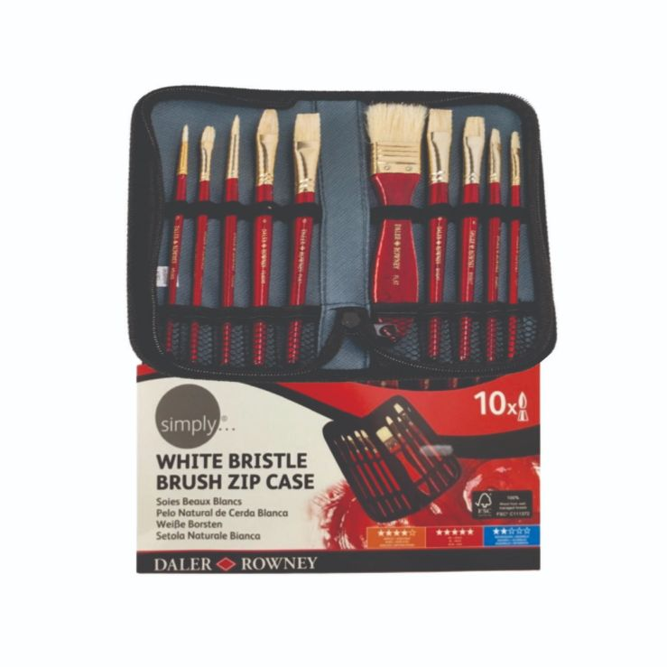

Price: PKR 4160

Description:

Achieve precise brushwork with DALER ROWNEY WHITE BRISTLE BRUSH. Its high-quality bristles make it an excellent choice for professional artists.



**Universal Stationary**

Deer Glider Fountain Pen Blue Ink (60ml)



Price: PKR 55

Description:

Experience smooth writing with Deer Glider Fountain Pen. The rich blue ink adds a touch of elegance to your writing.



**Universal Stationary**

Deer Super Excel Jar(48 PCS)



Price: PKR 590

Description:

Deer Super Excel Jar offers 48 high-quality pens, making it an economical choice for offices, schools, or personal use.



**Universal Stationary**

Deer Super Excel Rubber Tip Jar(48 Pcs)

Price: PKR 630

Description:

Deer Super Excel Rubber Tip Jar includes 48 pens with rubber tips, providing a comfortable writing experience for users.



**Universal Stationary**

Deer Topper Jar(Water jug jar)(48 pcs)



Price: PKR 790

Description:

Deer Topper Jar is shaped like a water jug, adding a playful touch to your workspace. It contains 48 pens, ensuring you're always well-stocked.



**Universal Stationary**

Deer Ultrafine Ball pen Black(10 pcs)pkt



Price: PKR 180

Description:

Deer Ultrafine Ball pen is perfect for precise writing. The pack of 10 ensures you always have a reliable pen at hand.



**Universal Stationary**

Deer Victory Ball pen red



Price: PKR 200

Description:

Deer Victory Ball pen in red offers smooth ink flow and vibrant color, making your writing stand out.



**Universal Stationary**

Deli Rotary Pencil Sharpener [IP][1Pc]



Price: PKR 1040

Description:

Deli Rotary Pencil Sharpener is a reliable tool for maintaining sharp pencil points. Its efficient design is suitable for various pencil sizes.



**Universal Stationary**

Derwent Compressed Charcoal Soft Box Of 6



Price: PKR 2650

Description:

Explore the world of charcoal art with Derwent Compressed Charcoal Soft. The set of 6 provides a range of tones for expressive drawings.



**Universal Stationary**

Derwent Graphatint Pencil Set (colored soluble graphite pencil)



Price: PKR 5550

Description:

Derwent Graphatint Pencil Set offers water-soluble graphite pencils in various colors, adding a unique dimension to your sketches..



**Universal Stationary**

Derwent Kneadable Eraser



Price: PKR 390

Description:

Derwent Kneadable Eraser is essential for artists. Its pliable texture allows you to shape it for precision erasing, making it ideal for detailed work.



**Universal Stationary**

Derwent Sketching Collection Set (3 sizes)(Set of 12)



Price: PKR 4500

Description:

Derwent Sketching Collection Set includes 12 pencils in different sizes, offering flexibility for various sketching techniques.



**Universal Stationary**

Derwent Sketching Collection Set (3 sizes)(Set of 24)



Price: PKR 8900

Description:

The Derwent Sketching Collection Set now offers 24 pencils in different sizes, providing even more options for your sketching endeavors.



**Universal Stationary**

Derwent Sketching Collection Set (3 sizes)(Set of 72)

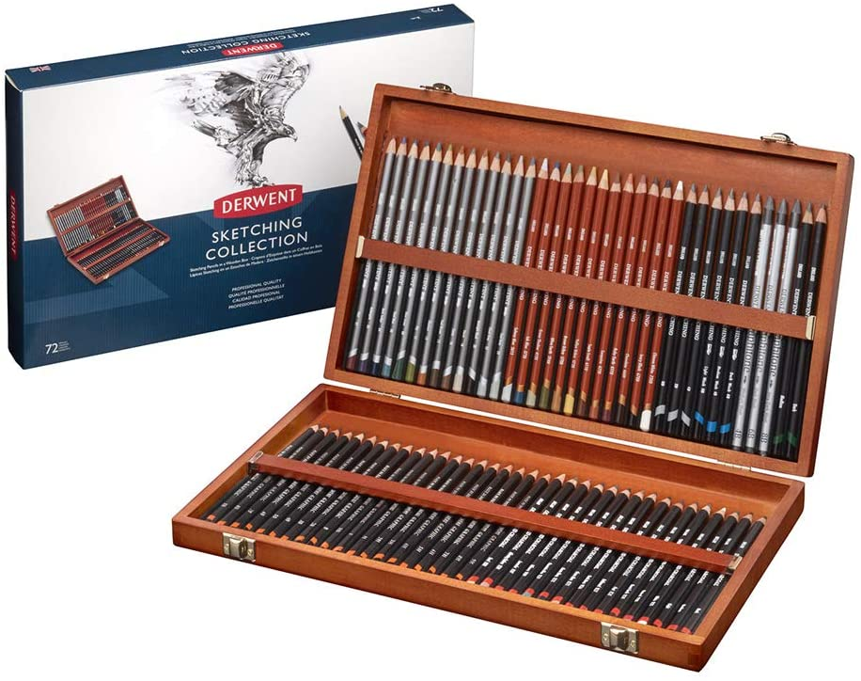

Price: PKR 45000

Description:

For serious sketching enthusiasts, the Derwent Sketching Collection Set now includes 72 pencils in different sizes, ensuring you have the perfect tool for every artistic expression.



**Universal Stationary**

Digital Scientific Calculator 240 Functions 82MS Statistics Mathematics 2Line Display for Student [PD][1Pc]



Price: PKR 480

Description:

The Digital Scientific Calculator is designed for students, featuring 240 functions, statistics, and a 2-line display for efficient mathematical tasks.



**Universal Stationary**

Dollar Ball Pen BP-3 10's Regular Box



Price: PKR 231

Description:

The Dollar Ball Pen BP-3 comes in a pack of 10, providing reliable ballpoint pens for everyday writing.



**Universal Stationary**

Dollar Fountain Pen 717i Transparent 10's Display Pack



Price: PKR 578

Description:

The Dollar Fountain Pen 717i Transparent comes in a display pack of 10, offering a unique and stylish writing instrument.



**Universal Stationary**

Dollar Fountain Pen Ink 30ml 12's Box



Price: PKR 435

Description:

The Dollar Fountain Pen Ink comes in a box of 12, providing ample ink supply for your fountain pens.



**Universal Stationary**

Dollar Fountain Pen SP-10 Rainbow Plus 10's Display Pack



Price: PKR 528

Description:

The Dollar Fountain Pen SP-10 Rainbow Plus comes in a display pack of 10, featuring a range of colors for a vibrant writing experience.



**Universal Stationary**

Dollar Gel Pen GL-1 10's Regular Box



Price: PKR 555

Description:

The Dollar Gel Pen GL-1 comes in a pack of 10, offering smooth and reliable gel pens for a comfortable writing experience.



**Universal Stationary**

Dollar My pencil PH-456 [IP]



Price: PKR 228

Description:

The Dollar My pencil PH-456 is a high-quality pencil, perfect for writing and drawing. It comes in individual packaging for added protection.



**Universal Stationary**

Dollar My Pointer Erasable 4s Polybag



Price: PKR 92

Description:

The Dollar My Pointer Erasable Pencil Set comes in a polybag of 4, providing convenient erasable pencils for various applications.



**Universal Stationary**

Dollar Pointer WOW 10's



Price: PKR 259

Description:

The Dollar Pointer WOW comes in a pack of 10, featuring vibrant colored pencils for artistic creations and everyday writing.



**Universal Stationary**

DOLLAR Stapler Pins ST24 1 Box



Price: PKR 100

Description:

The DOLLAR Stapler Pins ST24 come in a box, providing a reliable supply of stapler pins for your stapler.



**Universal Stationary**

Dollar WOW My Pencil PT-111 [IP][Pack]



Price: PKR 240

Description:

The Dollar WOW My Pencil PT-111 comes in individual packaging, offering a wow-inspiring set of high-quality pencils for various applications.



**Universal Stationary**

DUAL-HOLE CYLINDRICAL - SHARPENER

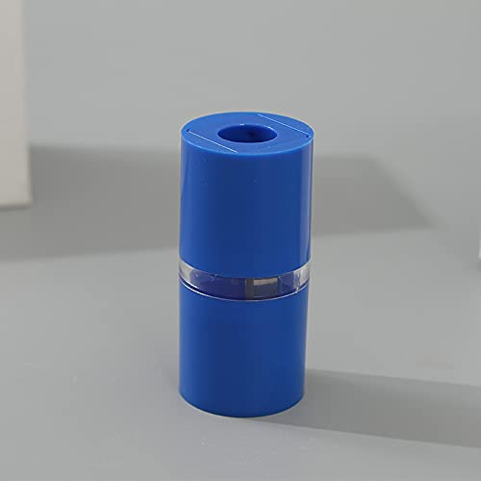

Price: PKR 350

Description:

The DUAL-HOLE CYLINDRICAL SHARPENER is a versatile tool that accommodates two pencil sizes. Its cylindrical design adds a touch of style to your stationery collection.



**Universal Stationary**

DUX Chrome Sharpener [IS]



Price: PKR 13

Description:

The DUX Chrome Sharpener is a compact and reliable sharpener with a chrome finish, ensuring durability and efficiency.



**Universal Stationary**

Dux Pencil Eraser Dx-45 [IP]



Price: PKR 7

Description:

The Dux Pencil Eraser Dx-45 is a simple yet effective eraser for everyday use. It comes in individual packaging for convenience.



**Universal Stationary**

DUX Ruler transparent 12"" (30cm)

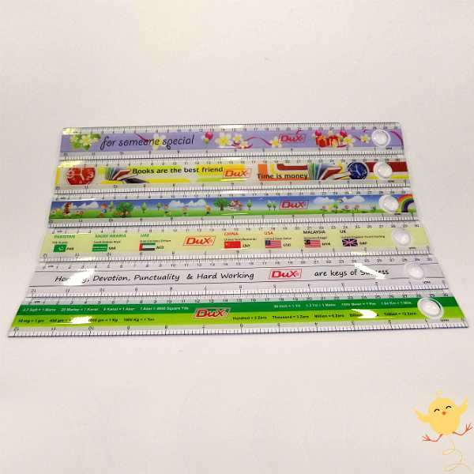

Price: PKR 45

Description:

The DUX Ruler is a transparent 12-inch ruler, ideal for precise measurements. Its clear design allows for easy visibility while working on projects.



**Universal Stationary**

FABER CASTELL ACRYLIC COLORS

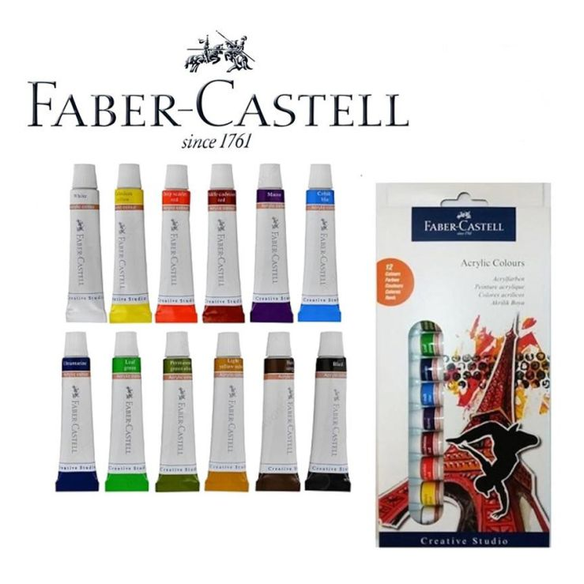

Price: PKR 1250

Description:

FABER CASTELL ACRYLIC COLORS offer high-quality pigments for vibrant and long-lasting results. This set is a must-have for artists seeking professional-grade acrylic colors.



**Universal Stationary**

Faber Castell Kneadable Art Eraser Grey



Price: PKR 375

Description:

The Faber Castell Kneadable Art Eraser in Grey is a versatile tool for artists. Its kneadable nature allows for precise erasing and shaping, making it essential for detailed work.



**Universal Stationary**

FABER CASTELL LATEX FREE ERASER



Price: PKR 55

Description:

The FABER CASTELL LATEX FREE ERASER provides clean and smudge-free erasing without latex. It's an essential tool for artists and students.



**Universal Stationary**

Fashion Foiled Journal Notebook Style 1



Price: PKR 590

Description:

The Fashion Foiled Journal Notebook in Style 1 features a fashionable design with foiled elements, making it a stylish accessory for your notes and sketches.



**Universal Stationary**

Fashion Foiled Journal Notebook Style 2



Price: PKR 435

Description:

The Fashion Foiled Journal Notebook in Style 2 combines chic design with foiled details. It's a trendy choice for those who appreciate style in their stationery.



**Universal Stationary**

Ferenu Engineer Scale

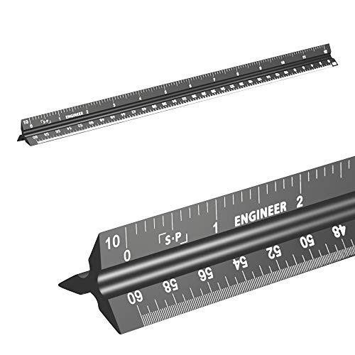

Price: PKR 3500

Description:

The Ferenu Engineer Scale is designed for precise measurements in engineering and architectural work. Its



**Universal Stationary**

Gold Foil Dots Journal Notebook



Price: PKR 430

Description:

The Gold Foil Dots Journal Notebook features a sophisticated design with gold foil dots, adding an elegant touch to your writing or sketching.



**Universal Stationary**

Gold Star Spiral Mix Media Pad



Price: PKR 1800

Description:

The Gold Star Spiral Mix Media Pad is perfect for mixed media art. With a spiral binding and quality paper, it provides a reliable surface for your creative projects.



**Universal Stationary**

Graphite Pencil Set of 12



Price: PKR 1800

Description:

The Graphite Pencil Set of 12 offers a classic selection of pencils for drawing and sketching. With various hardness grades, it's suitable for artists of all levels.



**Universal Stationary**

Hard Cover Sketchbook 50 Sheets

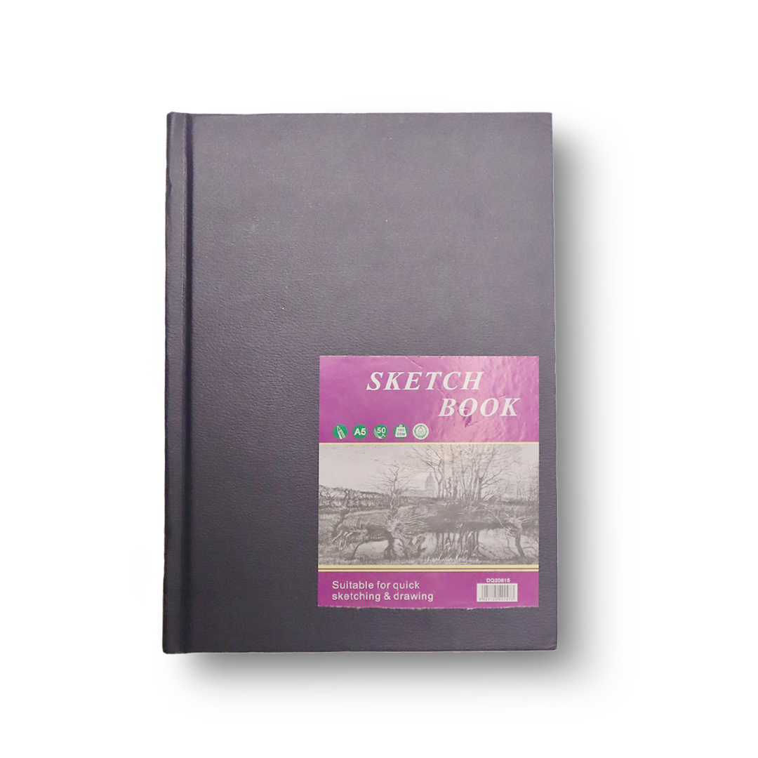

Price: PKR 1500

Description:

The Hard Cover Sketchbook with 50 sheets is a durable and reliable sketchbook for artists. Its hard cover provides extra protection for your artwork.



**Universal Stationary**

KEEP SMILING ACRYLIC PAINT SET 12X6ML

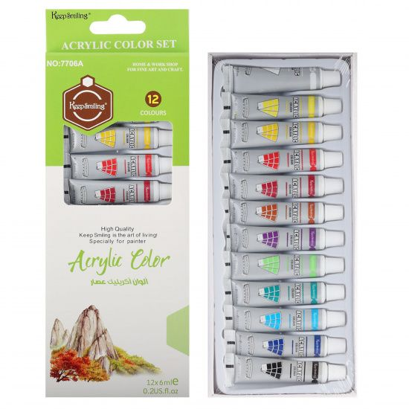

Price: PKR 370

Description:

The KEEP SMILING ACRYLIC PAINT SET features 12 vibrant colors in 6ml tubes, making it an affordable choice for artists exploring acrylic painting.



**Universal Stationary**

KEEP SMILING ARTIST ROUND BRUSH 5001 SET 13 PCS

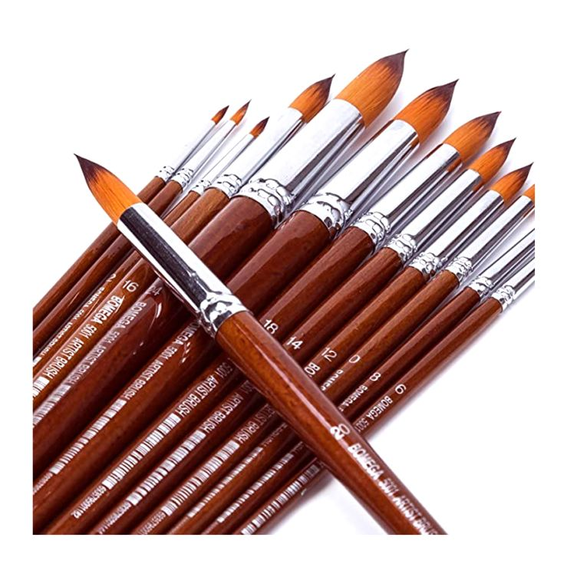

Price: PKR 1950

Description:

The KEEP SMILING ARTIST ROUND BRUSH 5001 SET includes 13 round brushes, offering a variety of sizes for different painting techniques.



**Universal Stationary**

Keep Smiling Compressed Charcoal 6 Pcs Set



Price: PKR 450

Description:

The Keep Smiling Compressed Charcoal Set includes 6 pieces, providing artists with versatile options for expressive charcoal drawings.



**Universal Stationary**

Keep Smiling Professional Sketchbook A4

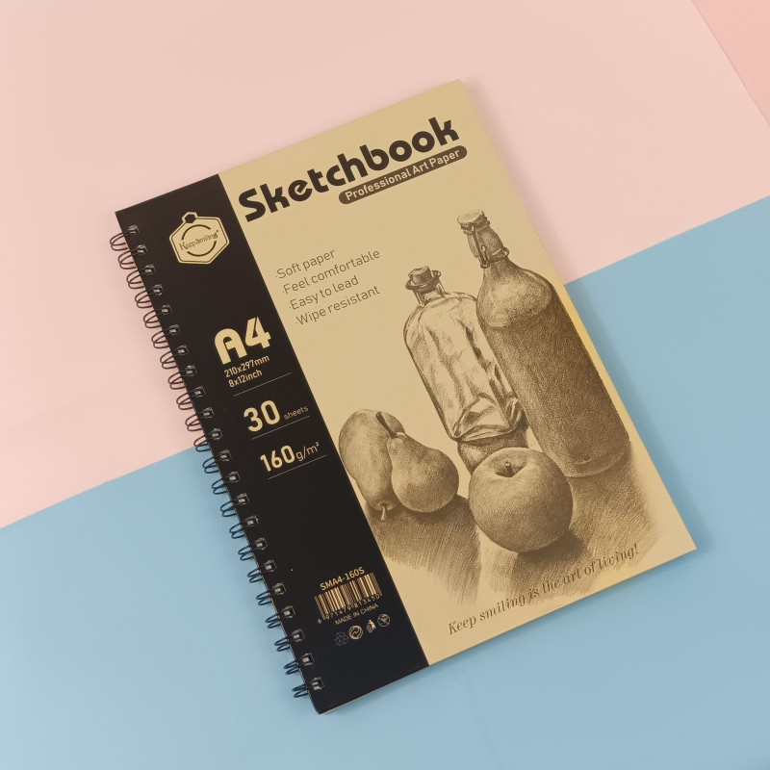

Price: PKR 999

Description:

The Keep Smiling Professional Sketchbook in A4 size offers high-quality paper for professional sketches. With 100 pages, it's a reliable companion for artists.



**Universal Stationary**

Keep Smiling Professional Sketchbook A5

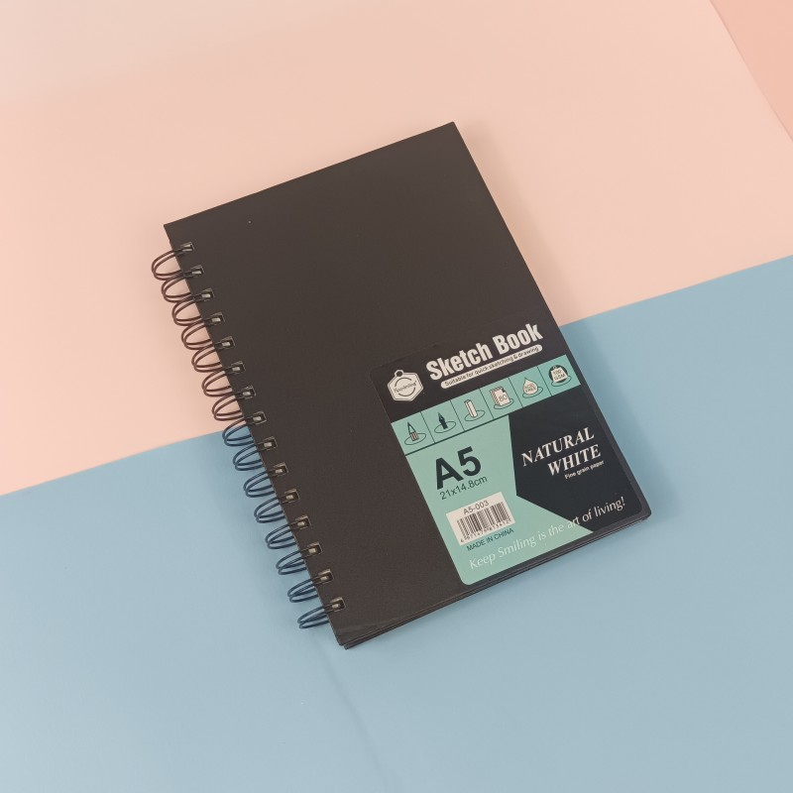

Price: PKR 1100

Description:

The Keep Smiling Professional Sketchbook in A5 size is a compact yet professional choice for artists. With 100 pages, it's suitable for various artistic projects.



**Universal Stationary**

KEEP SMILING WOODLESS GRAPHITE PENCILS PACK OF 6



Price: PKR 849

Description:

The KEEP SMILING WOODLESS GRAPHITE PENCILS come in a pack of 6, offering a woodless design for uninterrupted drawing. Ideal for shading and bold strokes.



**Universal Stationary**

Lyra Groove Twin Hole Sharpener



Price: PKR 700

Description:

The Lyra Groove Twin Hole Sharpener is a stylish and functional sharpener with two holes, catering to different pencil sizes. Its grooved design adds a touch of uniqueness.



**Universal Stationary**

M&G 02 Mini Stapler 246



Price: PKR 175

Description:

The M&G 02 Mini Stapler 246 is a compact and portable stapler, perfect for on-the-go use. Despite its size, it provides efficient stapling for your documents.



**Universal Stationary**

M&G Stapler 246 Brilliant



Price: PKR 395

Description:

The M&G Stapler 246 Brilliant combines style and functionality. With a sleek design, it adds a touch of elegance to your workspace while offering reliable stapling.



**Universal Stationary**

M&G Stapler Pin 246



Price: PKR 60

Description:

The M&G Stapler Pin 246 comes in a pack, providing a convenient supply of stapler pins for your M&G stapler.



**Universal Stationary**

Marie's Charcoal Pencil Box



Price: PKR 950

Description:

Marie's Charcoal Pencil Box includes a set of professional-grade charcoal pencils, perfect for achieving deep and expressive tones in your drawings.



**Universal Stationary**

MONT MARTE ACRYLIC COLOUR PAINT SET SIGNATURE 6PC X 75ML MSCH6751

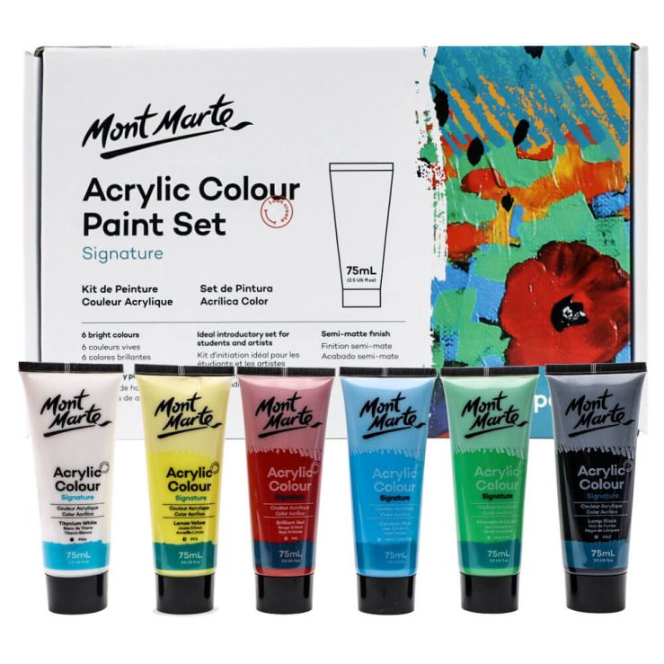

Price: PKR 2395

Description:

MONT MARTE ACRYLIC COLOUR PAINT SET SIGNATURE includes 6 vibrant colors in 75ml tubes, allowing artists to create signature pieces with high-quality pigments.



**Universal Stationary**

MONT MARTE ARTIST BRUSH TAKLON ROUND



Price: PKR 260

Description:

MONT MARTE ARTIST BRUSH TAKLON ROUND is a versatile round brush suitable for various painting techniques. Its high-quality bristles ensure smooth and precise strokes.



**Universal Stationary**

Mont Marte Artist Canvas Pine Frame Double Thick Signature



Price: PKR 1195

Description:

The Mont Marte Artist Canvas with Pine Frame offers a double-thick surface for artists. With a sturdy frame, it provides stability for your artistic endeavors.



**Universal Stationary**

MONT MARTE DIMENSION ACRYLIC PAINT 250ML

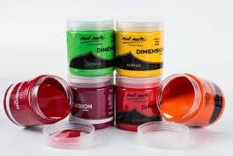

Price: PKR 1580

Description:

MONT MARTE DIMENSION ACRYLIC PAINT in 250ml tubes adds texture and depth to your paintings. With a range of colors, it's perfect for creating visually stunning artworks.



**Universal Stationary**

Mont Marte Electric Eraser With 30 Pieces Refills



Price: PKR 1730

Description:

The Mont Marte Electric Eraser comes with 30 refill pieces, providing artists with a convenient and efficient tool for erasing with precision.



**Universal Stationary**

MONT MARTE GALLERY SERIES ACRYLIC ROUND BRUSH SET 6PCS



Price: PKR 600

Description:

MONT MARTE GALLERY SERIES ACRYLIC ROUND BRUSH SET includes 6 brushes designed for acrylic painting. Their high-quality construction ensures smooth application of paint.



**Universal Stationary**

MONT MARTE GLITTER PAINT 12PC X 36ML

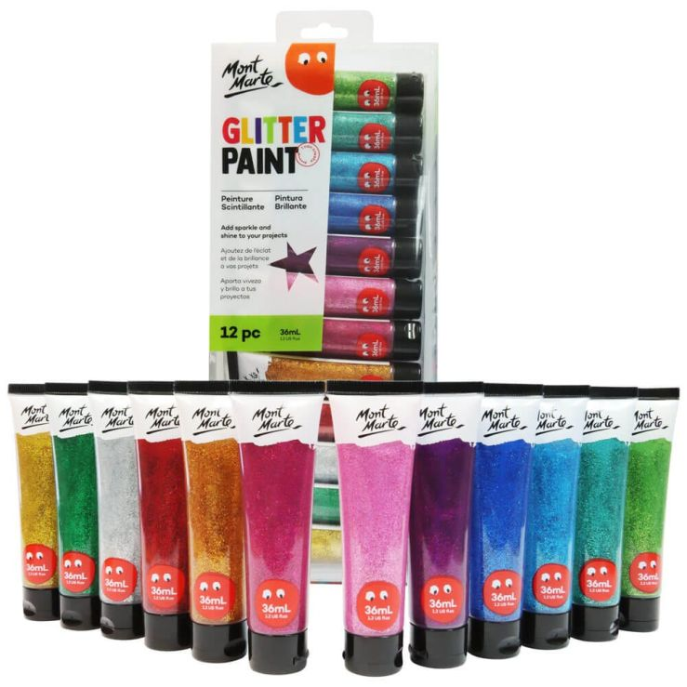

Price: PKR 2850

Description:

MONT MARTE GLITTER PAINT SET includes 12 colors in 36ml tubes, allowing artists to add a touch of sparkle to their creations. Ideal for various art projects.



**Universal Stationary**

Mont Marte Hard Bound Sketchbook 80 Pages 110gsm

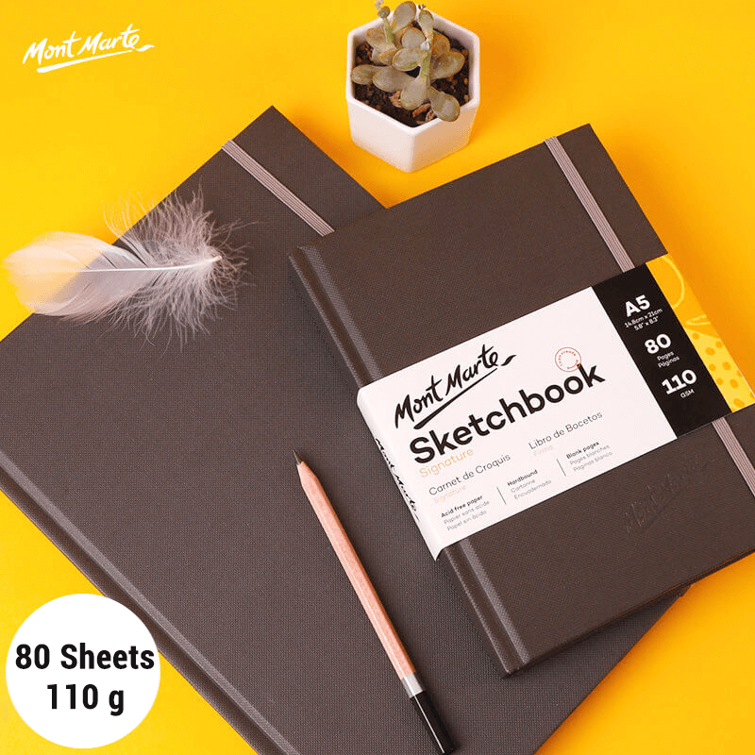

Price: PKR 3200

Description:

The Mont Marte Hard Bound Sketchbook offers 80 pages of 110gsm paper, providing a premium surface for your sketches. Its hardcover ensures durability and protection.



**Universal Stationary**

MONT MARTE METALLIC ACRYLIC PAINT 50ML

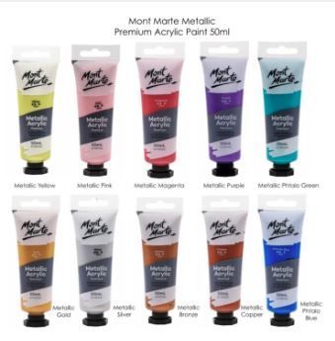

Price: PKR 495

Description:

MONT MARTE METALLIC ACRYLIC PAINT in 50ml tubes adds a metallic touch to your artwork. With a range of colors, it's perfect for creating artworks with a lustrous finish.



**Universal Stationary**

Mont Marte Signature Sketching Journal 100 Pages 150gsm

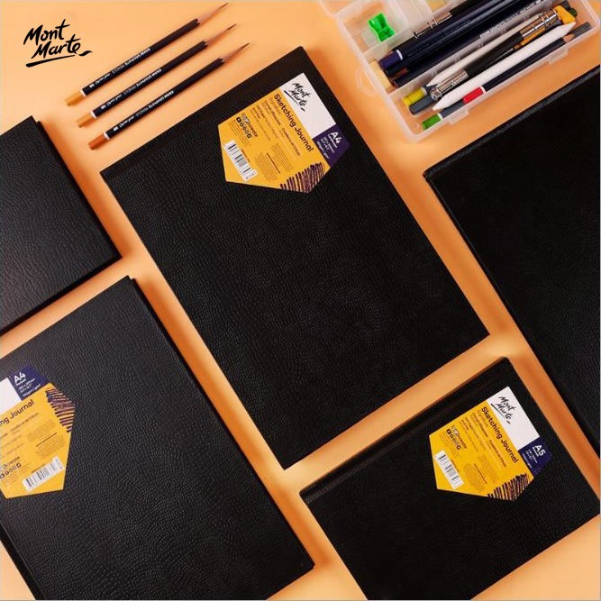

Price: PKR 2990

Description:

The Mont Marte Signature Sketching Journal features 100 pages of 150gsm paper, providing a premium surface for your sketches. With a stylish cover design, it's an elegant addition to your art collection.



**Universal Stationary**

MONT MARTE WATER BRUSH SET



Price: PKR 1260

Description:

The Mont Marte Water Brush Set includes brushes suitable for watercolor painting. With a convenient water reservoir, artists can create beautiful watercolor effects on the go.



**Universal Stationary**

Original Casio fx-570ES PLUS 2nd Edition Scientific Calculator 417 Functions [IP][1Pc]



Price: PKR 3450

Description:

The Original Casio fx-570ES PLUS is a 2nd Edition Scientific Calculator with 417 Functions, making it a reliable tool for students and professionals in various mathematical tasks.



**Universal Stationary**

Oro 2010 Colorful Erasers 80 Pcs

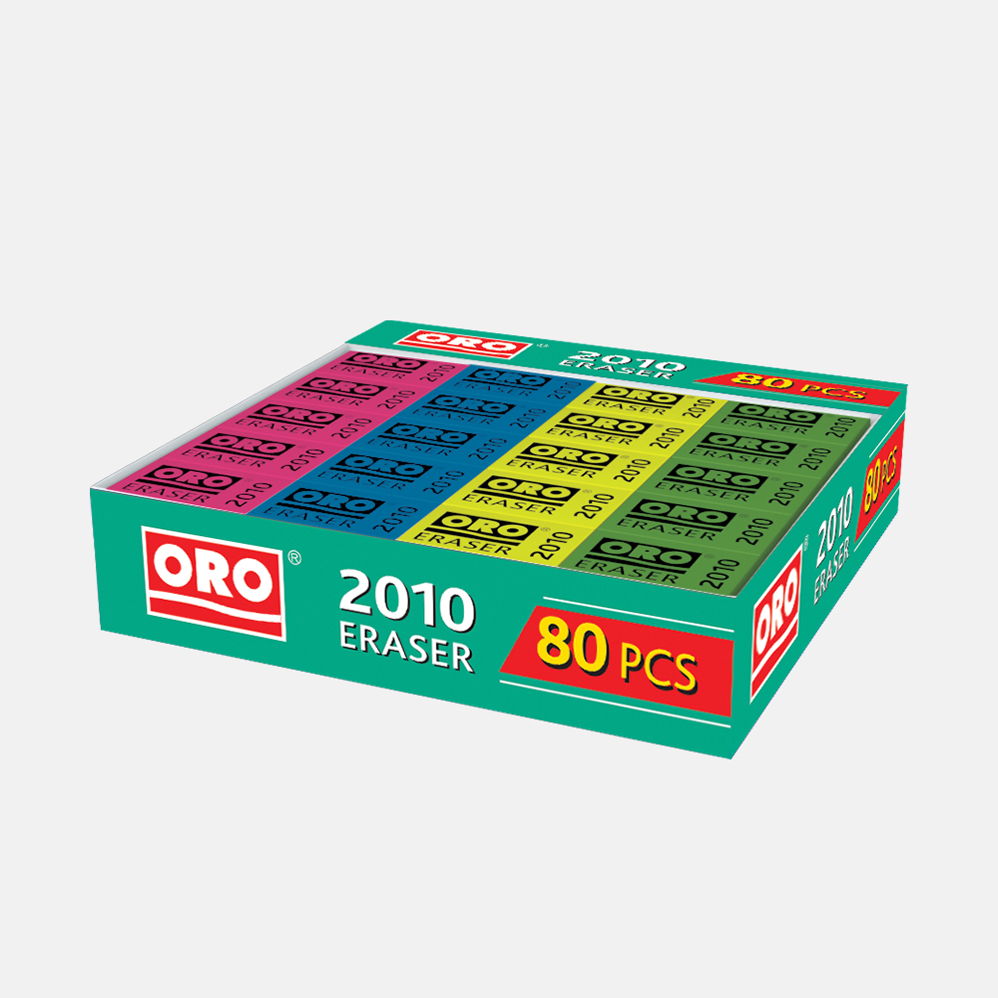

Price: PKR 360

Description:

The Oro 2010 Colorful Erasers come in a pack of 80, providing users with a vibrant and practical erasing solution for drawings, sketches, and written work.



**Universal Stationary**

ORO 6 Inch Plastic Ruler

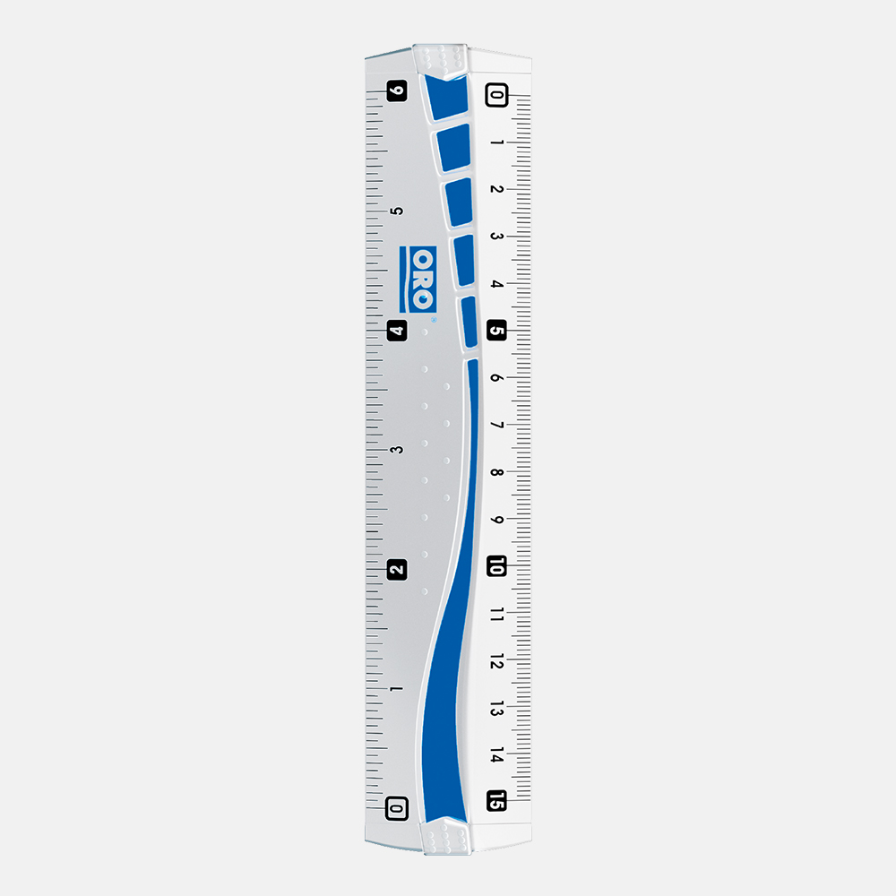

Price: PKR 35

Description:

The ORO 6 Inch Plastic Ruler is a simple yet essential tool for precise measurements. Made of durable plastic, it serves as a reliable ruler for various tasks.



**Universal Stationary**

Oro Granite Pack of 12 Pencils

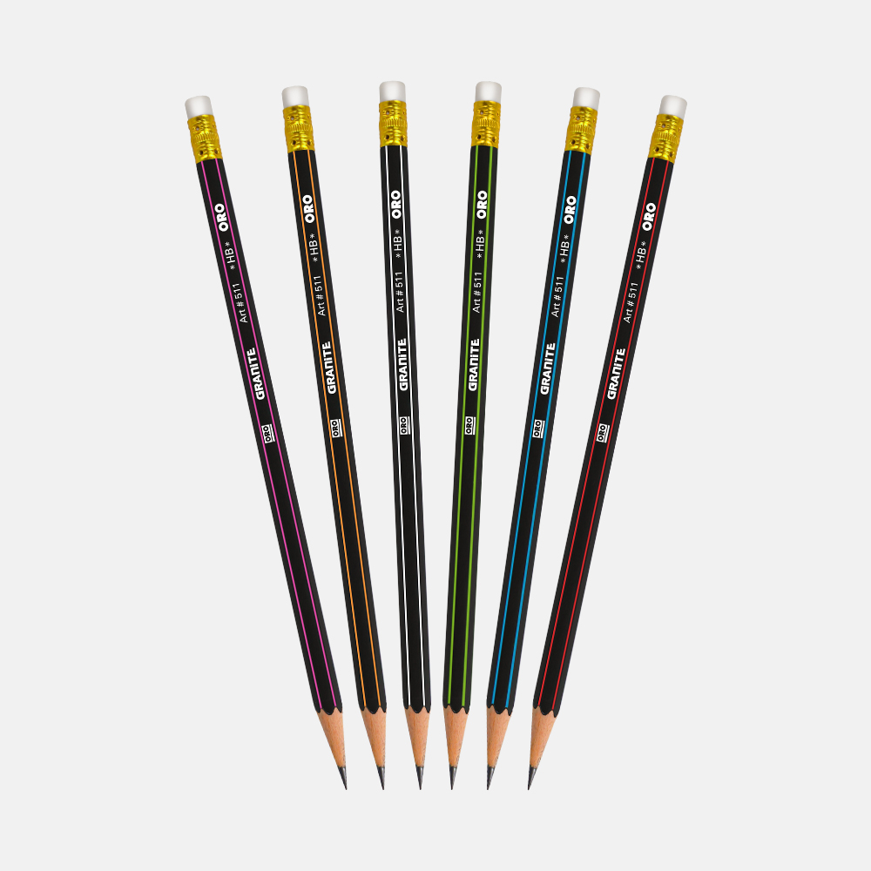

Price: PKR 220

Description:

The Oro Granite Pack of 12 Pencils offers a set of quality pencils suitable for various artistic and writing applications.



**Universal Stationary**

Oro Loopers Bulb Small Jar of 48 Pencils

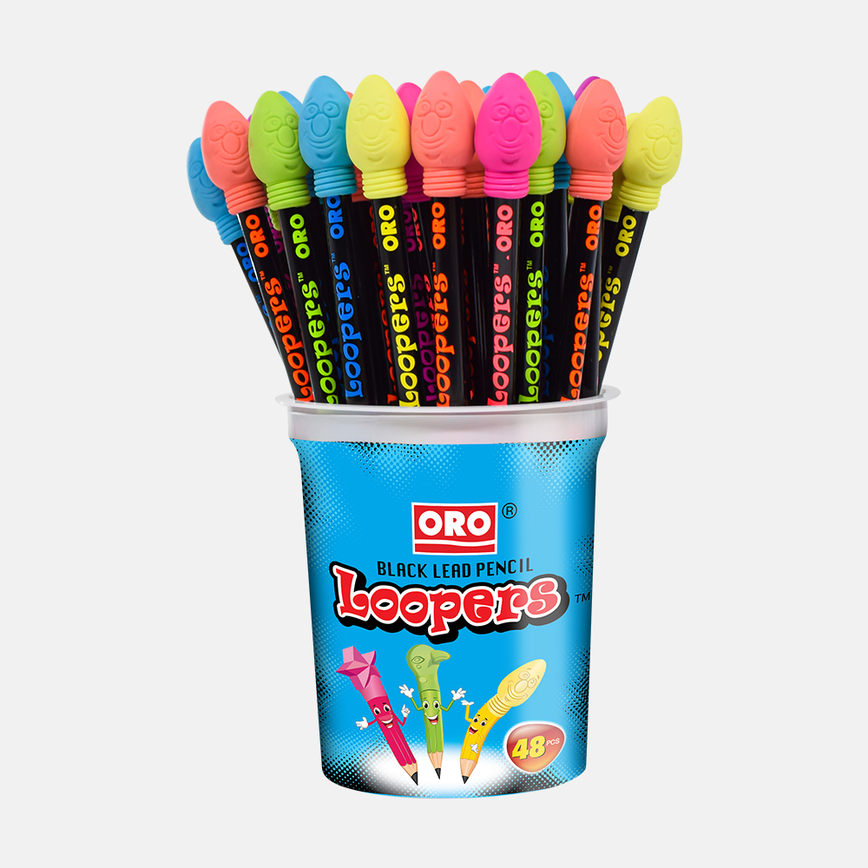

Price: PKR 1000

Description:

The Oro Loopers Bulb Small Jar includes 48 pencils, providing artists with a colorful and versatile set for their creative projects.



**Universal Stationary**

Oro Loopers Star Small Pencils Jar – 48pcs

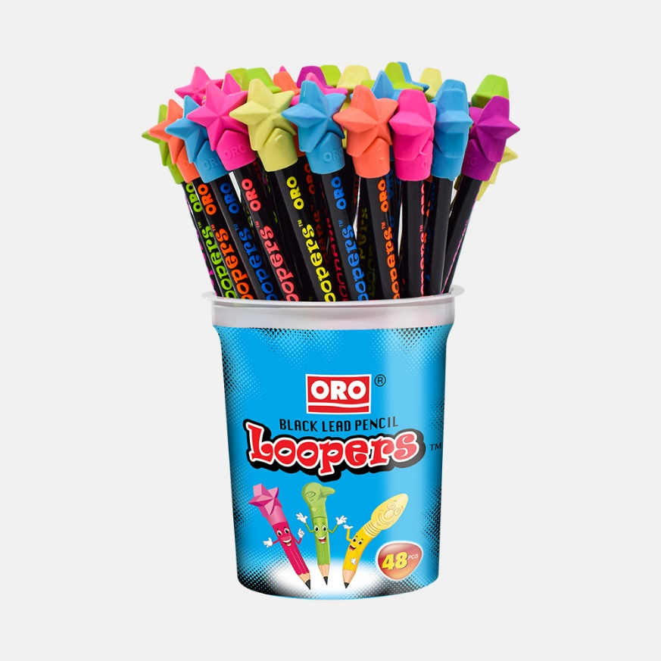

Price: PKR 1000

Description:

The Oro Loopers Star Small Pencils Jar contains 48 star-patterned pencils, offering a unique and playful addition to an artist's pencil collection.



**Universal Stationary**

Oro Reeko 20 Sharpener Box

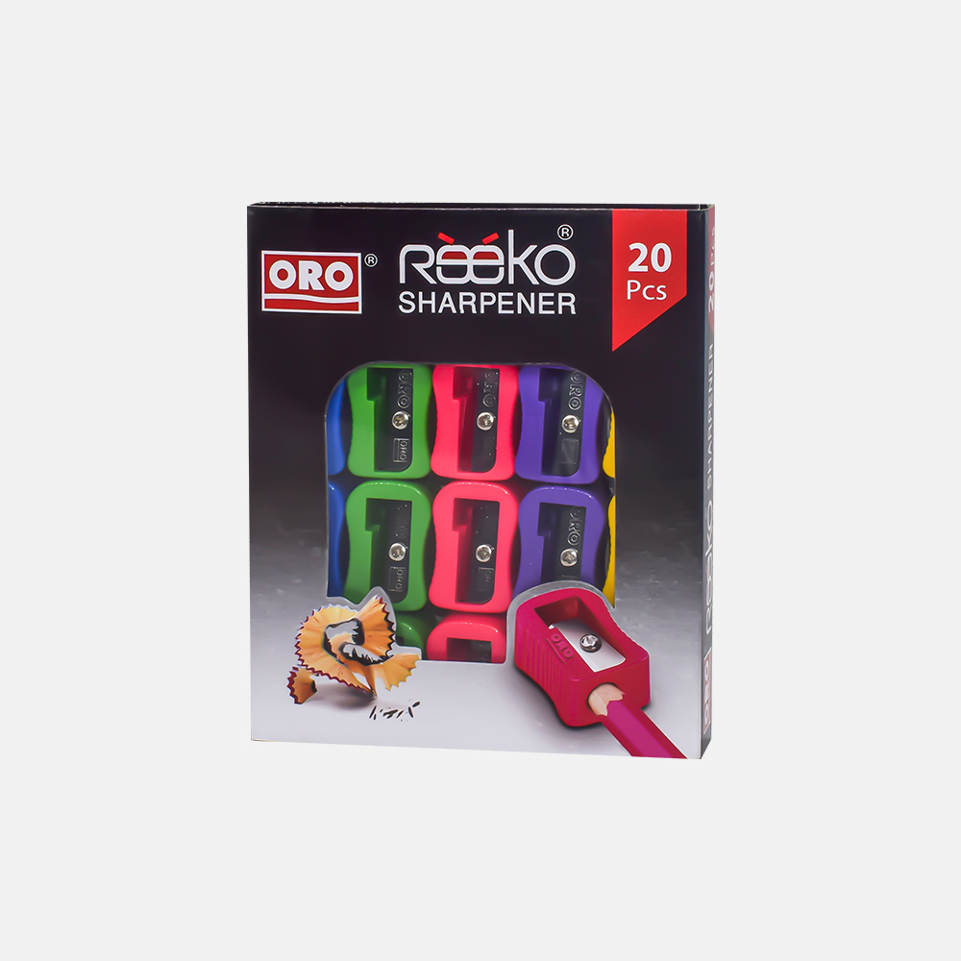

Price: PKR 200

Description:

The Oro Reeko 20 Sharpener Box includes 20 sharpeners, offering a convenient and economical solution for keeping pencils sharp and ready for use.



**Universal Stationary**

Oro Veezo Erasers

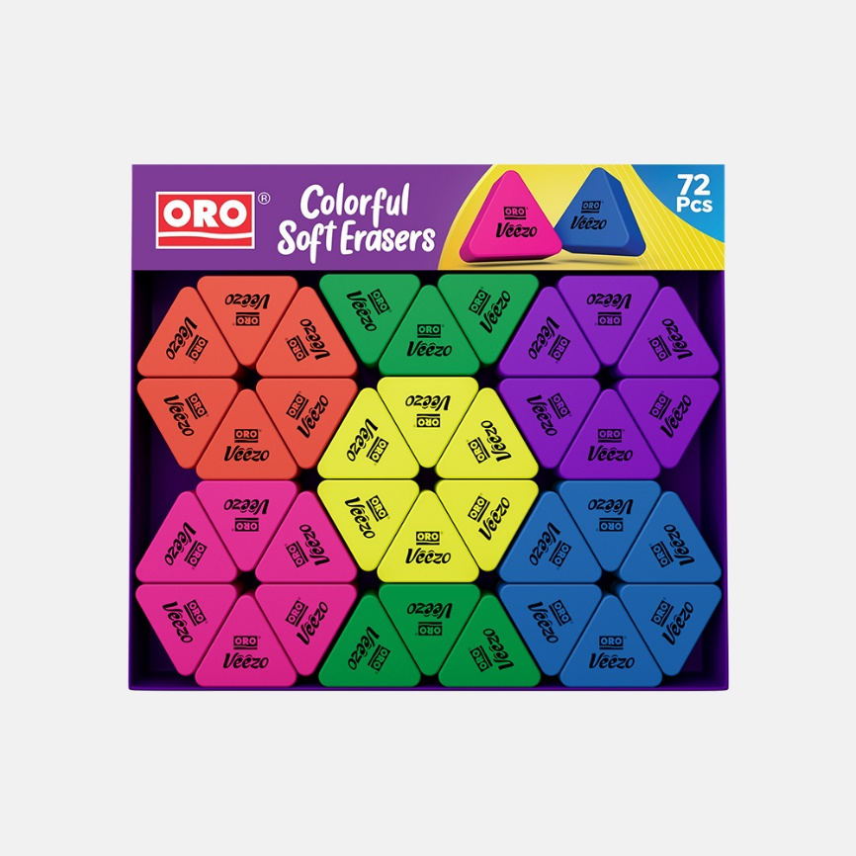

Price: PKR 330

Description:

The Oro Veezo Erasers provide users with a reliable and efficient erasing tool. With a smooth erasing action, they are suitable for various artistic and writing purposes.



**Universal Stationary**

Oro Zippy Pencil Sharpener

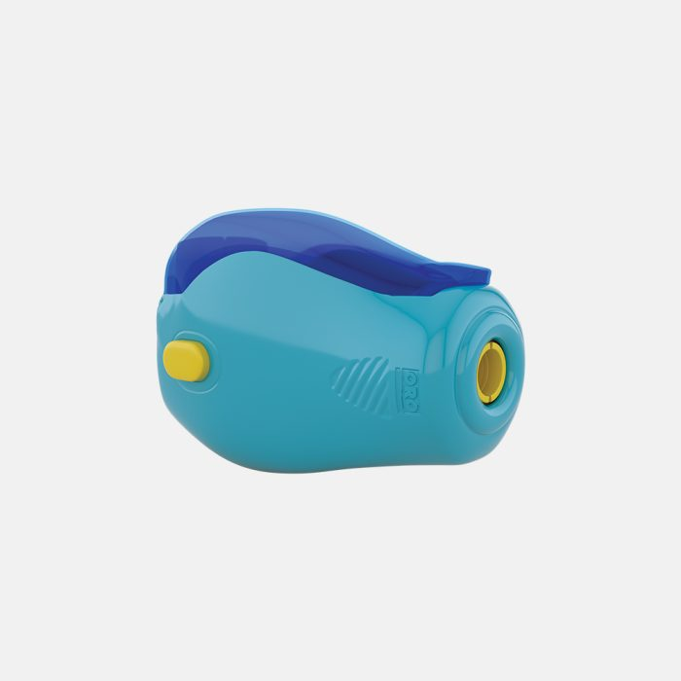

Price: PKR 55

Description:

The Oro Zippy Pencil Sharpener is a compact and portable sharpener designed for easy and efficient sharpening of pencils.



**Universal Stationary**

Piano A Star Fountain Pen Single Piece



Price: PKR 45

Description:

The Piano A Star Fountain Pen is a single-piece pen featuring a classic design. With smooth ink flow, it offers a pleasant writing experience.



**Universal Stationary**

Piano Factis Erasers WR-01(Pack of 12)



Price: PKR 310

Description:

The Piano Factis Erasers WR-01 come in a pack of 12, providing users with high-quality erasers suitable for artistic and writing applications.



**Universal Stationary**

Piano Fountain Pen 10pcs Set



Price: PKR 310

Description:

The Piano Fountain Pen 10pcs Set includes a collection of fountain pens, each offering a smooth and consistent writing experience.



**Universal Stationary**

Piano Jelflo Ballpoint Pen Pack of 10



Price: PKR 285

Description:

The Piano Jelflo Ballpoint Pen Pack of 10 features ballpoint pens known for their smooth writing and comfortable grip.



**Universal Stationary**

Piano Permanent Marker Blue Round Tip 70

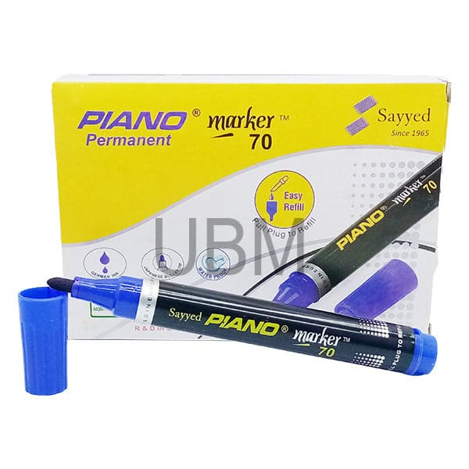

Price: PKR 60

Description:

The Piano Permanent Marker with a Blue Round Tip (Size 70) offers a bold and lasting ink mark, making it suitable for various writing and labeling tasks.



**Universal Stationary**

Piano Point Ballpoint Pen 0.8mm Pack of 10

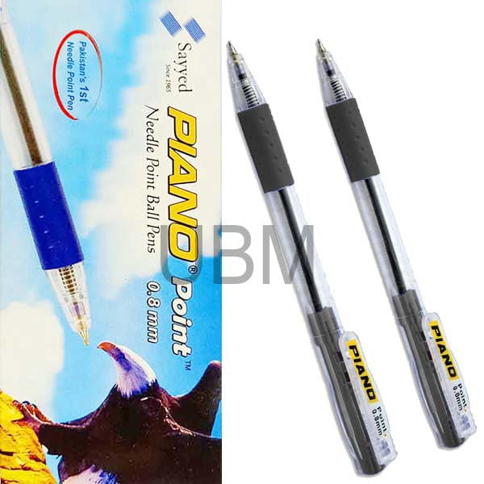

Price: PKR 150

Description:

The Piano Point Ballpoint Pen Pack of 10 includes ballpoint pens with a 0.8mm tip, providing users with a smooth and precise writing experience.



**Universal Stationary**

Piano Ruler Scale

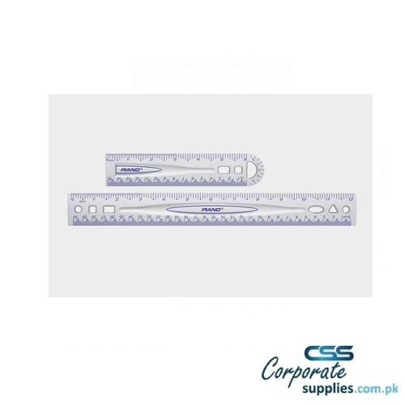

Price: PKR 50

Description:

The Piano Ruler Scale is a simple and essential tool for measuring and drawing straight lines. With a clear scale, it serves various purposes in artistic and educational tasks.



**Universal Stationary**

Piano Tempo Fountain Pen Single Piece

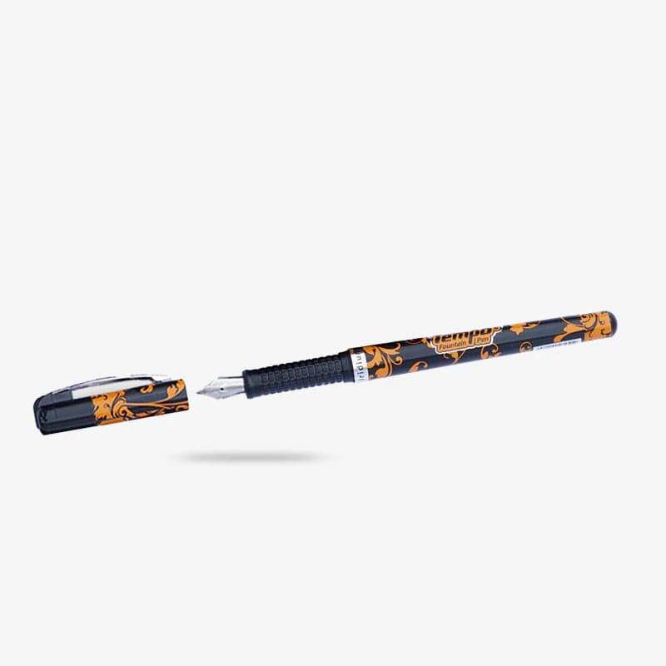

Price: PKR 75

Description:

The Piano Tempo Fountain Pen is a single-piece pen known for its elegance and smooth writing. It offers a classic and reliable writing instrument.



**Universal Stationary**

Piano Whiteboard Marker Ink 15ml



Price: PKR 75

Description:

The Piano Whiteboard Marker Ink comes in a 15ml bottle, providing a refill option for whiteboard markers. It ensures a consistent and bold ink flow.



**Universal Stationary**

Picasso Fineliner Pens - Perfect for Artists, Designers, and Writers Pack of 10 Pens



Price: PKR 400

Description:

The Picasso Fineliner Pens Pack of 10 is designed for artists, designers, and writers, offering fine lines and vibrant colors for creative projects.



**Universal Stationary**

Picasso Grip Ball Pen for Smooth and Comfortable Writing Experience Pack of 10 Pens



Price: PKR 195

Description:

The Picasso Grip Ball Pen Pack of 10 provides a smooth and comfortable writing experience with its ergonomic design. It is suitable for daily writing tasks.



**Universal Stationary**

PICASSO Staples PINS No.10 1 Box



Price: PKR 27

Description:

The PICASSO Staples PINS No.10 come in a box, providing users with a supply of staples for various stapling needs.



**Universal Stationary**

PU Leather Soft Cover Journal Notebook



Price: PKR 645

Description:

The PU Leather Soft Cover Journal Notebook features a stylish and durable cover. With quality paper, it offers a comfortable writing and sketching experience.



**Universal Stationary**

RULERS Steel Scale 12

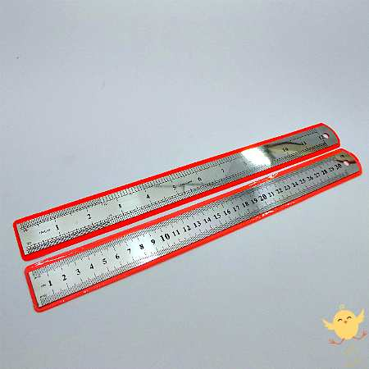

Price: PKR 65

Description:

The RULERS Steel Scale 12 is a durable steel ruler designed for precise measurements and drawing straight lines.



**Universal Stationary**

SAKURA ACRYLIC COLOR



Price: PKR 350

Description:

The SAKURA ACRYLIC COLOR is a set of acrylic colors, offering vibrant and versatile options for artists engaged in painting and artistic projects.



**Universal Stationary**

Shalaku Mechanical Pencil



Price: PKR 130

Description:

The Shalaku Mechanical Pencil is a reliable tool for precise and controlled drawing and writing tasks.



**Universal Stationary**

Shiny Silver Journal Notebook



Price: PKR 430

Description:

The Shiny Silver Journal Notebook features a stylish silver cover, making it an attractive and functional choice for note-taking and sketching.



**Universal Stationary**

SINOART ARTIST BRUSHES SET 12 PCS

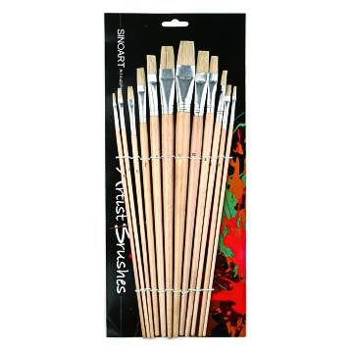

Price: PKR 550

Description:

The SINOART ARTIST BRUSHES SET includes 12 brushes suitable for various artistic techniques. With different brush shapes and sizes, it caters to artists' diverse needs.



**Universal Stationary**

SINOART TAKLON BRUSH SHORT HANDLE SET 18 PCS

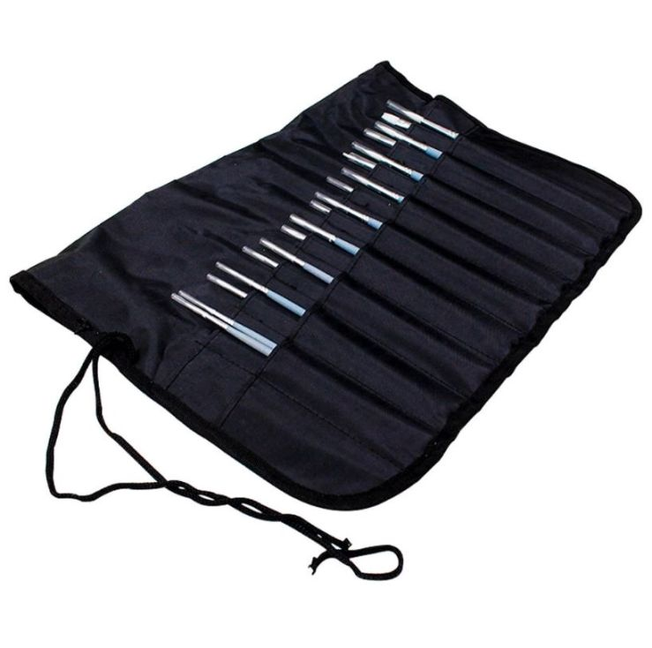

Price: PKR 1395

Description:

The SINOART TAKLON BRUSH SHORT HANDLE SET includes 18 brushes with short handles, providing artists with a versatile set for different painting techniques.



**Universal Stationary**

ST Hard Bound Sketchbook 150gsm 54 Sheets

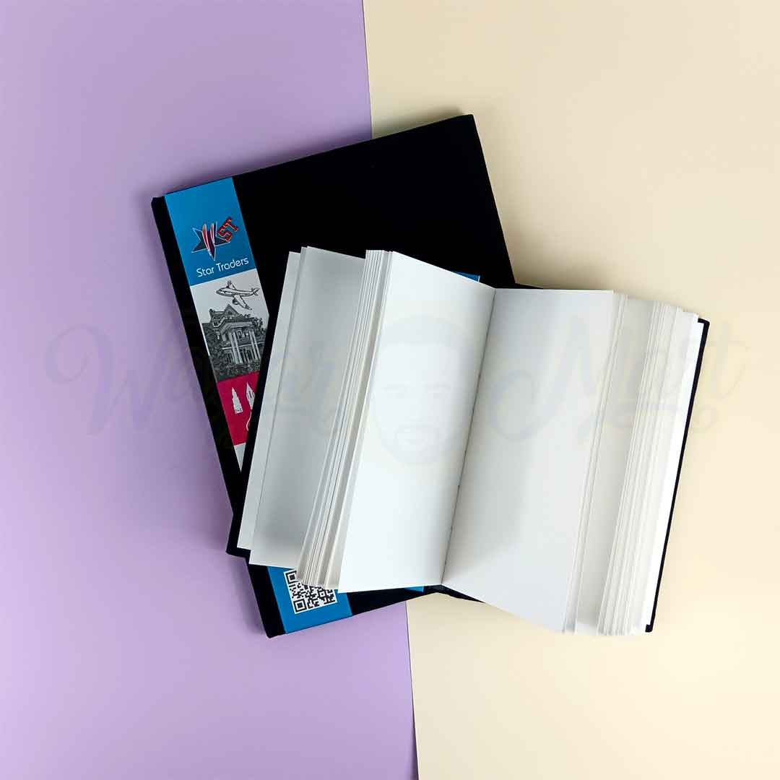

Price: PKR 1350

Description:

The ST Hard Bound Sketchbook features 54 sheets of 150gsm paper, offering artists a high-quality surface for sketching and drawing.



**Universal Stationary**

STAEDTLER ( 2 HOLES ) GRAPHITE - SHARPENER



Price: PKR 426

Description:

The STAEDTLER (2 HOLES) GRAPHITE SHARPENER is a pencil sharpener designed specifically for graphite pencils, ensuring a sharp and precise point for detailed work.



**Universal Stationary**

STAEDTLER GRAPHITE - SHARPENER



Price: PKR 240

Description:

The STAEDTLER GRAPHITE SHARPENER is designed for sharpening graphite pencils. It provides a clean and sharp point for a smooth drawing and writing experience.



**Universal Stationary**

Superb Fine Quality Canvas Board

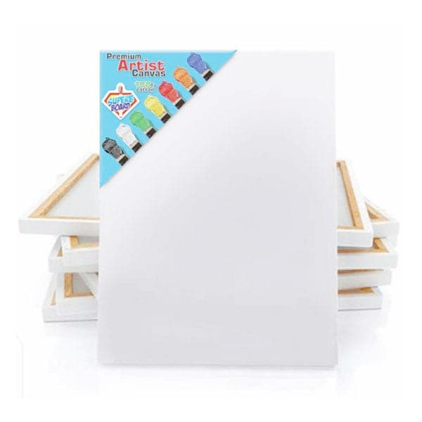

Price: PKR 125

Description:

The Superb Fine Quality Canvas Board is a canvas surface mounted on a sturdy board, providing artists with a convenient and durable support for their paintings.



**Universal Stationary**

Triangular Architect Scale Ruler



Price: PKR 499

Description:

The Triangular Architect Scale Ruler is a specialized ruler designed for architects and engineers. With different scales, it facilitates accurate and precise measurements in technical drawings.



**Universal Stationary**

TSC Spiral Notebook Style 181



Price: PKR 550

Description:

The TSC Spiral Notebook Style 181 is a spiral-bound notebook suitable for note-taking and sketching. It features quality paper for a smooth writing and drawing experience.



**Universal Stationary**

TSC Spiral Notebook Style 196



Price: PKR 550

Description:

The TSC Spiral Notebook Style 196 is a spiral-bound notebook designed for various writing and sketching purposes. It provides users with a convenient and portable writing surface.



**Universal Stationary**

TSC Spiral Notebook Style 203



Price: PKR 550

Description:

The TSC Spiral Notebook Style 203 is a spiral-bound notebook featuring quality paper for a comfortable writing and sketching experience.



**Universal Stationary**

TSC Spiral Notebook Style 206



Price: PKR 550

Description:

The TSC Spiral Notebook Style 206 is a spiral-bound notebook suitable for various writing and drawing tasks. It offers a reliable and portable solution for note-taking and sketching.



**Universal Stationary**

USLON Superior Quality Graphite Pencils Set (8B-2H)

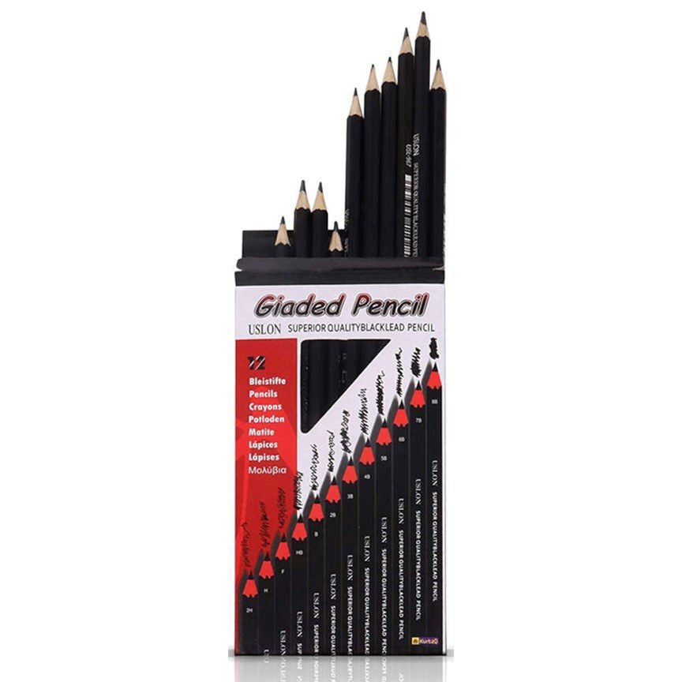

Price: PKR 300

Description:

The USLON Superior Quality Graphite Pencils Set includes pencils ranging from 8B to 2H, offering artists a diverse range of graphite hardness for different drawing techniques.



**Universal Stationary**

Wolf Box Drawing Set



Price: PKR 5000

Description:

The Wolf Box Drawing Set is a comprehensive drawing set that includes a variety of drawing tools, making it suitable for artists and enthusiasts looking for a complete drawing solution.



**Universal Stationary**

Worison Art Compressed Charcoal (6Pcs)



Price: PKR 500

Description:

The Worison Art Compressed Charcoal Set includes 6 compressed charcoal sticks, providing artists with versatile and rich drawing materials for charcoal-based artworks.